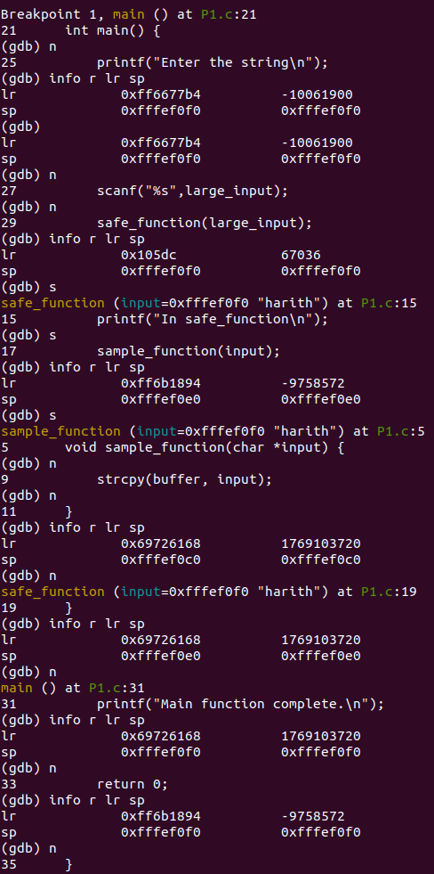
Q1)

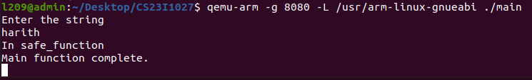

Q2)
If input is less than 10 characters:

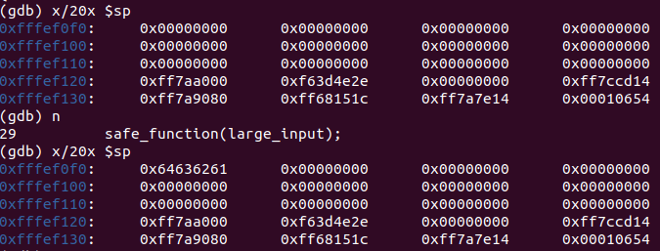

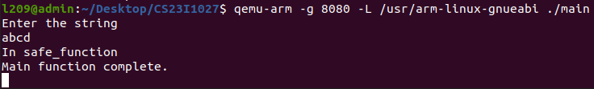

If input is more than 10 characters:
It will overflow the buffer, corrupting the stack.

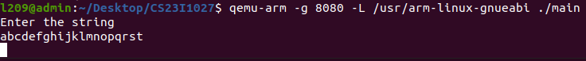
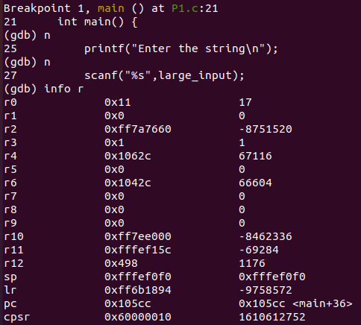

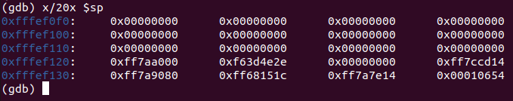
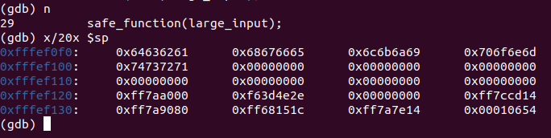

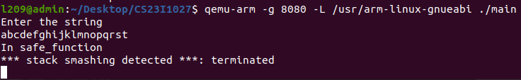
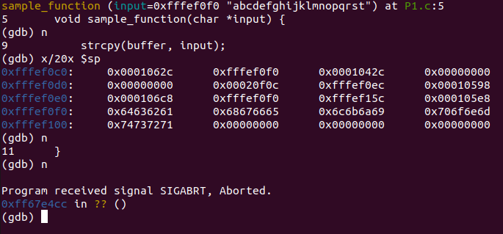
Q3)
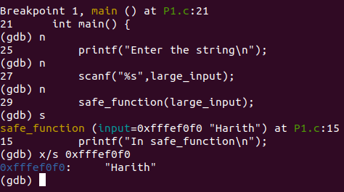
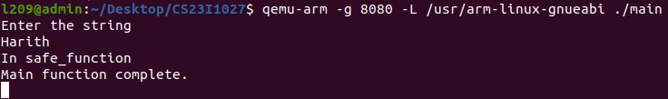

Q4)
We can replace the number of characters copied:
strncpy(buffer, input, sizeof(buffer) – 1);

Also ensure the null termination of the buffer array:
buffer[sizeof(buffer) - 1] = '\0';

Finally, Limit the size of characters inputted in scanf statement to prevent buffer overflow:
scanf("%99s", large_input);
(99 because the large input can take 100 characters.)

New Code:

#include <stdio.h>
#include <string.h>

void sample_function(char *input) {
char buffer[10];
strncpy(buffer, input, sizeof(buffer) - 1);
buffer[sizeof(buffer) - 1] = '\0';
}

void safe_function(char *input) {
printf("In safe_function\n");
sample_function(input);
}

int main() {
char large_input[100];
printf("Enter the string\n");
scanf(" %99s", large_input);
safe_function(large_input);
printf("Main function complete.\n");

return 0;
}

Error Found:

The error is a buffer overflow error, which is occured when the input data is given beyond the bounds of a fixed-size buffer. This causes corruption of adjacent memory, leading to stack smashing, which then ultimately leads to unexpected program termination.

